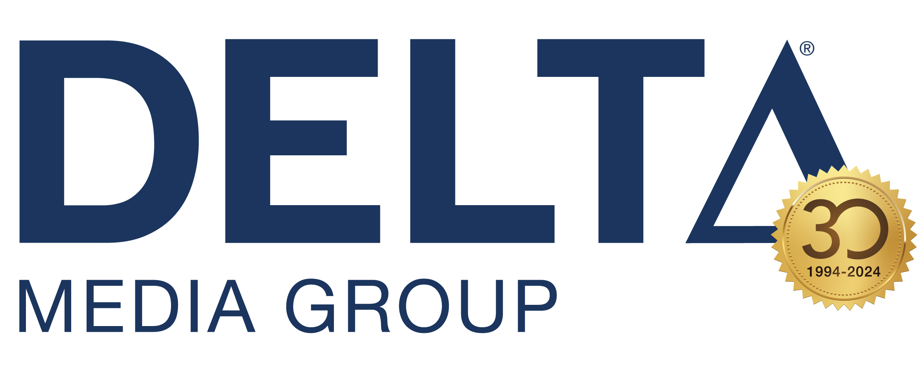

Corporate Fact Sheet

Who: Delta Media Group, Inc.
Creators of DeltaNET all-in-one marketing technology platform, real estate’s easiest to use CRM, digital marketing tools, superpowered-SEO and website solution.

What: Delta Media Group is a leading and trusted technology partner for many of real estate’s best brands and creator of the DeltaNET, real estate’s most advanced all-in-one platform. Its latest technology, DeltaNET 7, is the industry’s easiest to use CRM, digital marketing tools, superpowered-SEO and website solution that leverages automation and AI (artificial intelligence). Today, Delta Media is the largest family-owned and operated technology innovator with no outside investors or VC funding. Delta Media is renowned for saving clients money while reducing the frustration of managing multiple online technologies through superior integration. Established in 1994, Delta Media remains a top real estate technology innovator.

Where: Delta Media Group is online at deltamediagroup.com.

Delta Media Group is based in Canton, Ohio, its own multi-story, 30,000 square foot Class A+ office building. Custom built for Delta Media, the modern building houses corporate offices and a 7,000 square foot state-of-the art data center that is one of the state’s most advanced hosting centers. It also features an elegantly designed two-story atrium, skylights, 14-foot ceilings, advanced security systems, Level 7 technology readiness, and a full 24/7/365 back-up power system.

Delta Media headquarters:
7015 Sunset Strip Ave NW
North Canton OH 44720

Hours of operation:
Monday – Friday
8:00 am – 6:00 pm (Eastern Time)

When: 1994 – The Delta Group, based in Beaverton, OR, launches its first online property search (created PropertyPuruit engine)
1998 – Rebrands as Tigerfly, Inc., moves to Sunnyvale, CA
2000 – Current owner Michael Minard, along with Jonathan Blood, Ernie Blood and James Bray, purchase TigerFly, rebrand as Delta Media Group, and relocates to Barberton, OH
2008 – Delta Media moves into its new headquarters and data center in Canton, OH
2016 – Minard acquires 100% of Delta Media, launches DeltaNET 5.0
2020 – After $30 million and 40,000 development hours, DeltaNET 6 is launched
2021 – Moves into its new headquarters; launched Local Showings
2023 – DeltaNET 7® launches. This new version of DeltaNET® is the easiest-to-use, most automated and customizable CRM platform for real estate available today.

Why: Delta Media Group develops technology to help make the real estate industry’s lives better. The only all-in-one platform provider in the real estate industry that is 100% family-owned and operated by its own CEO, Delta Media Group has no outside investors and no VC funding. Delta Media Group is a trusted technology partner for many of real estate’s top brands, serving more than 600 real estate brokerages with 35,000+ agents and over 225 MLSs (Multiple Listing Services), reaching 97% of all properties listed for sale in the U.S.

Its DeltaNET all-in-one platform, including the industry’s easiest to use CRM, digital marketing tools, superpowered-SEO and website solution provides advanced technology to brokerage clients, delivering a center of excellence to brokerages that drives success through artificial intelligence and machine learning.

A digital marketing agency with built-in CRM and SEO plus a tech support team all rolled into one solution, DeltaNET offers its unmatched creative content, superior data services and faster listing speed for the freshest information available. DeltaNET, its latest all-in-one platform, is a major advancement that represents over 40,000 development hours and an investment now totalling more than $40 million.

As major real estate brands acquire broker technology platforms exclusively for their franchises, Delta Media is seamlessly converting orphaned brokerages to its all-in-one DeltaNET solution, with the option to integrate with its Local Showings platform and app. Independent brokerages moving to Delta are able to regain brand differentiation and control, and most importantly maintain their traffic and SEO equity when transitioning to the real estate industry’s most advanced all-in-one digital marketing and website platform. Case studies prove Delta Media’s clients benefit from significant increases in total website traffic, new users, organic traffic and leads, created by superpowered SEO.

Leaders: Michael Minard, CEO and Owner

Editor’s Note: DeltaNET and DeltaNET 7 are registration-pending service marks of Delta Media Group.

Media contacts:
Victor Lund (805) 709-6696
victor@wavgroup.com

Kevin Hawkins (206) 866-1220
kevin@wavgroup.com

